**CIRCUIT DIAGRAM:**

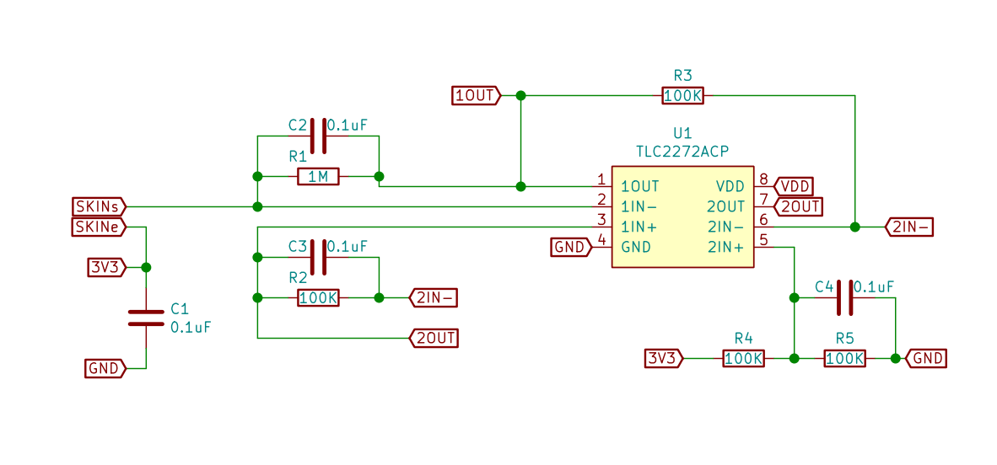

**PROPOSED PROTOTYPE:**

